Create a custom docker image for nginx and deploy it using docker-compose, where the volume mount should be at /var/opt/nginx location. Push the created custom docker image to your docker hub.

**Creating custom Images via Dockerfile and copying custom index.html**

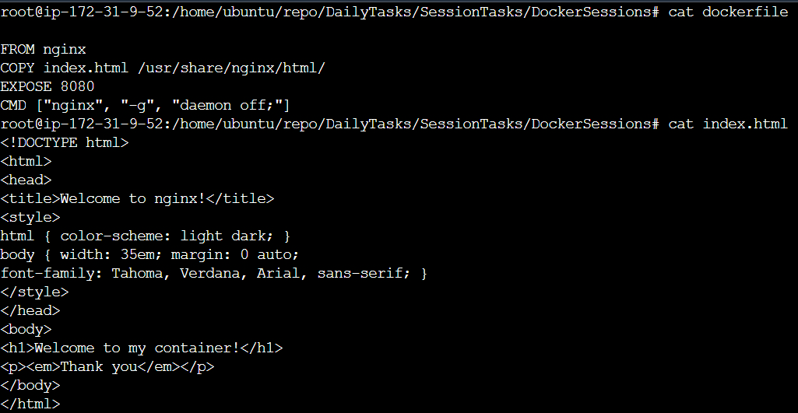

**Deploying container by docker-compose tool**

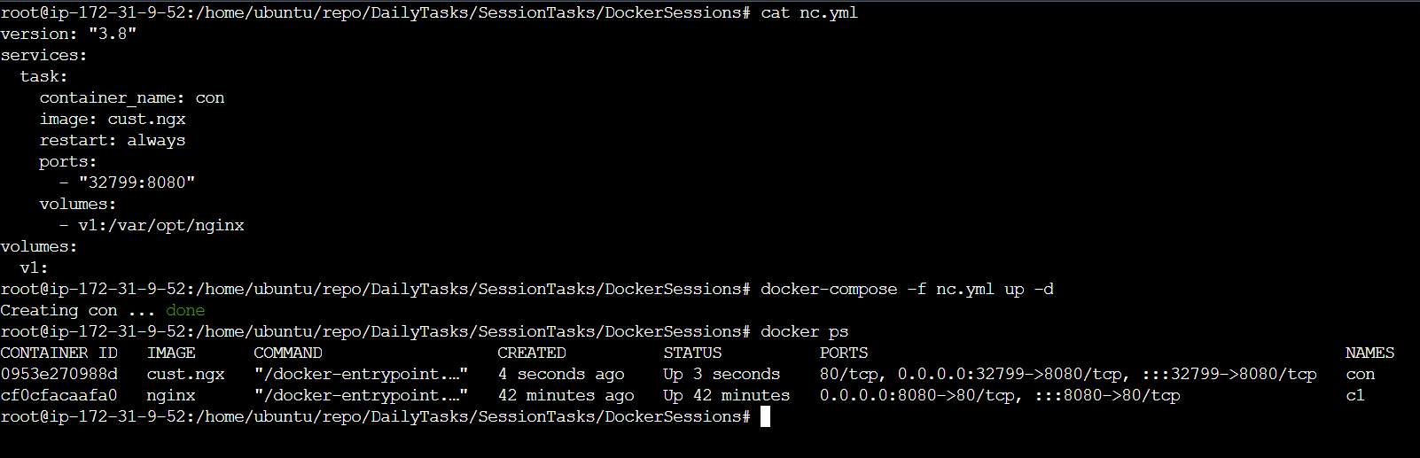

**Volume mount location :**

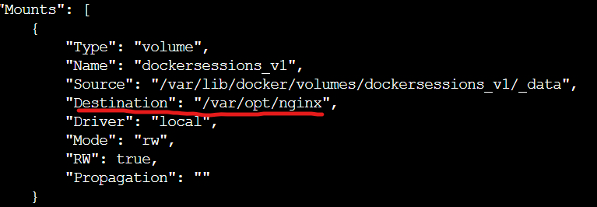

**Custom Image : cust.ngx**

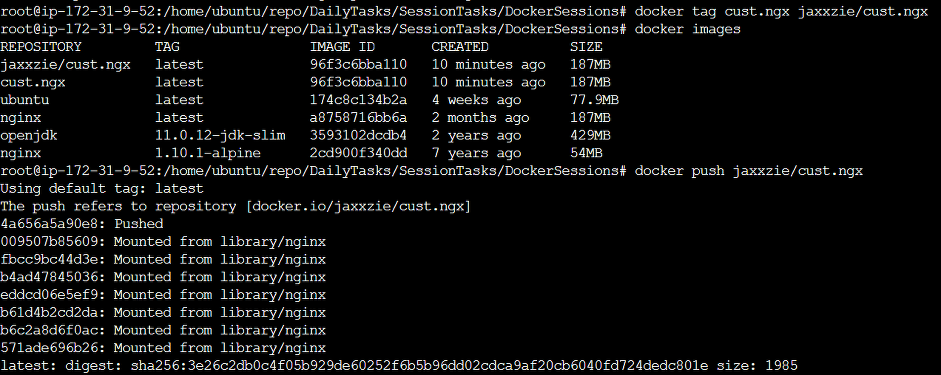

**Pushing cust.ngx to DockerHub :**

